Unit 12 Details

Large room which is set out in two areas. There is a large space which can hold up to ten fold out tables and roughly 50 guests that is suitable for events such as bingo nights etc.

The smaller section of the room can comfortably seat 15 people on our soft comfy corner sofa and seats set out in a way that is perfect for a ‘gather group’ there is plenty of space to sit, chat and have a cuppa tea 😊 there is also a large smart television on the wall which can allow linking up to zoom calls and presentations etc.

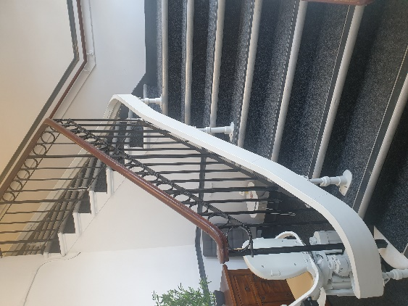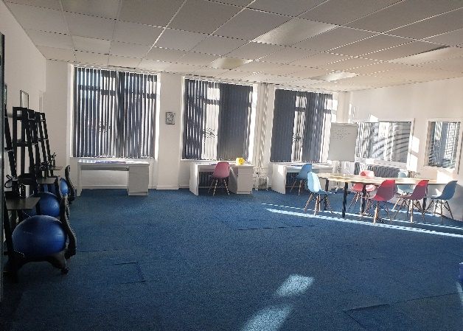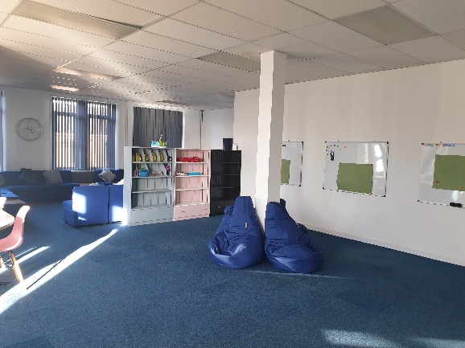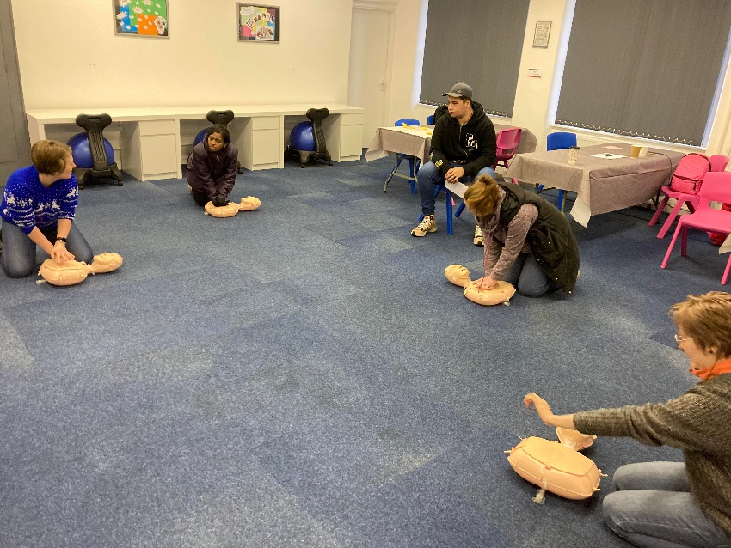Urn (hot water), teas and coffees and biscuits may be provided at an additional cost.